 DURATION: 90 MINUTES

MARKS : 100

**ENGG105 ENGINEERING DESIGN FOR SUSTAINABILITY**

**AUTOCAD LAB TEST**

* **PART A (80 MARKS):**

1. Draw the 2D drawing given below (Figure 1) using AutoCAD and dimension it.

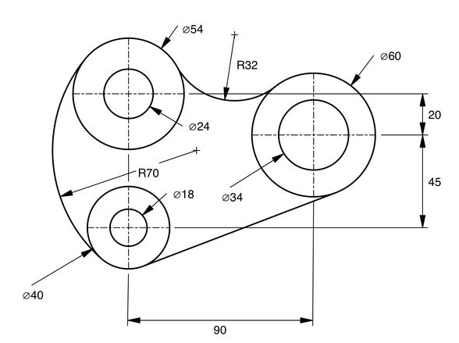

Figure 1

 DURATION: 90 MINUTES

MARKS : 100

* **PART B (20 MARKS):**

1. Draw the 3D model given below (Figure 2) using AutoCAD.

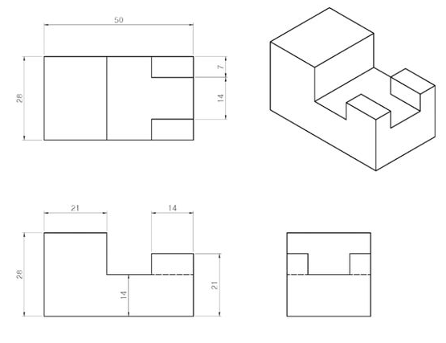

Front View

Side View

Top View

Figure 2